- Digital Twin

  - Introduction

Global industries have achieved a tremendous technological transformation due to the linkage between the digital and physical worlds. Digital twin technology has played an important role in enhancing this convergence.
This technology enables companies or organizations to develop digital copies of their products, assets, or processes to optimize performance and maintenance.

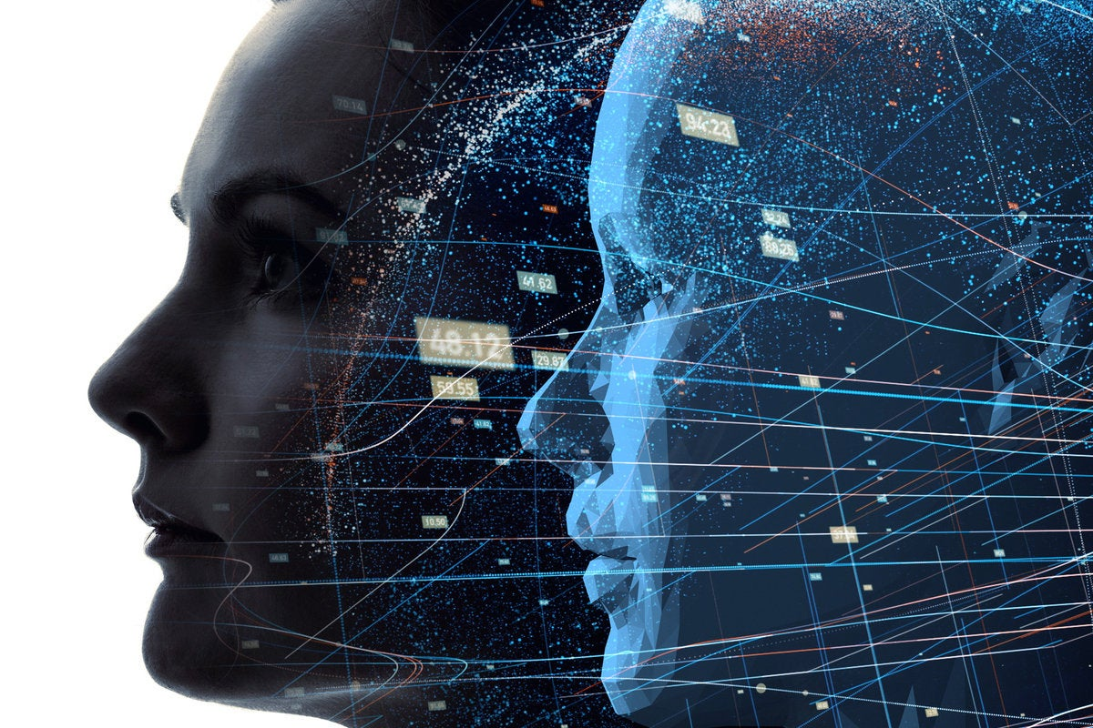

Figure 1: Digital Twin

  - How Digital Twin Technology Works

Digital twin technology works by integrating artificial intelligence, internet of things (IoT), and software analytics with physical assets or processes.
Physical products, devices, processes, or equipment are built with sensors to collect data. A cloud-based system is used to send this data to the digital world.
Machine learning algorithms are then used to analyze the collected data. This analysis generates actionable information that creates a digital copy of the physical world (physical asset, product, or process).
The digital twin generates insights to signify areas that need a change in the physical process or product.
Continuous analysis of real-time data ensures that the digital twin is up to date with the physical world’s current state
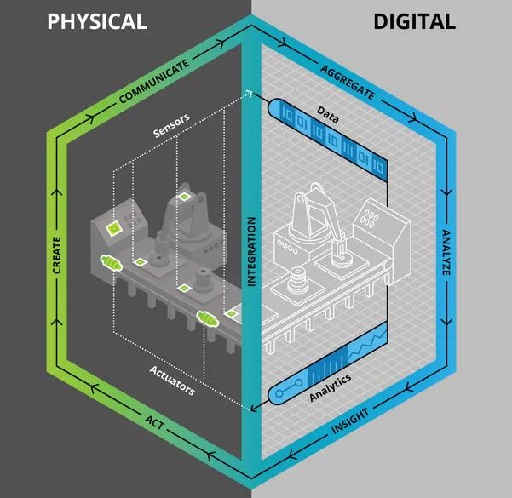
Figure 2:This show how the digital twin technology works

1.2.1 Sensors
Sensors are positioned at various points of the physical process to collect data. Some of the important dimensions of data collected include works in progress (including speed, thickness, and color quality), environmental conditions of the factory, and machines’ behavioral characteristics

1.2.2 Data
This is the information collected from the physical processes. The main data collected includes operational and environmental data. This data is aggregated and combined with other enterprise data such as design specifications, enterprise systems, engineering drawings, and customer logs.

    - Interaction
Interactive technology enhances the interaction between the physical processes and the digital representation of these processes. This technology enables sensors to communicate the data mentioned above to the virtual (digital) world. Some of the integration technologies used include edge, security, and communication interfaces.

    - Analytics
Data is analyzed through visualization routines and algorithmic simulations. Digital twins produce insights using this analysis. This analysis ensures the actual manufacturing process takes place seamlessly. It also identifies unacceptable trends in this process.

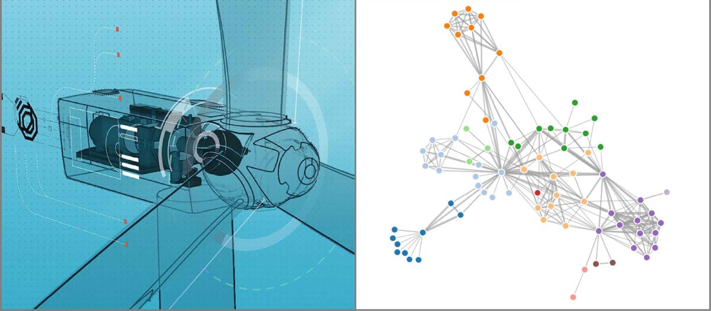

Figure 3: Digital Twin Data Analytics

    - Digital Twin
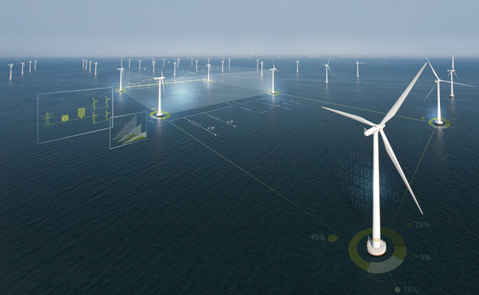
This is the digital replica of the actual manufacturing processes.

Figure 4: The Rise Of Digital Twin

    - Actuators
If there is any need for action in the actual process, the digital twin will use actuators to generate the action.

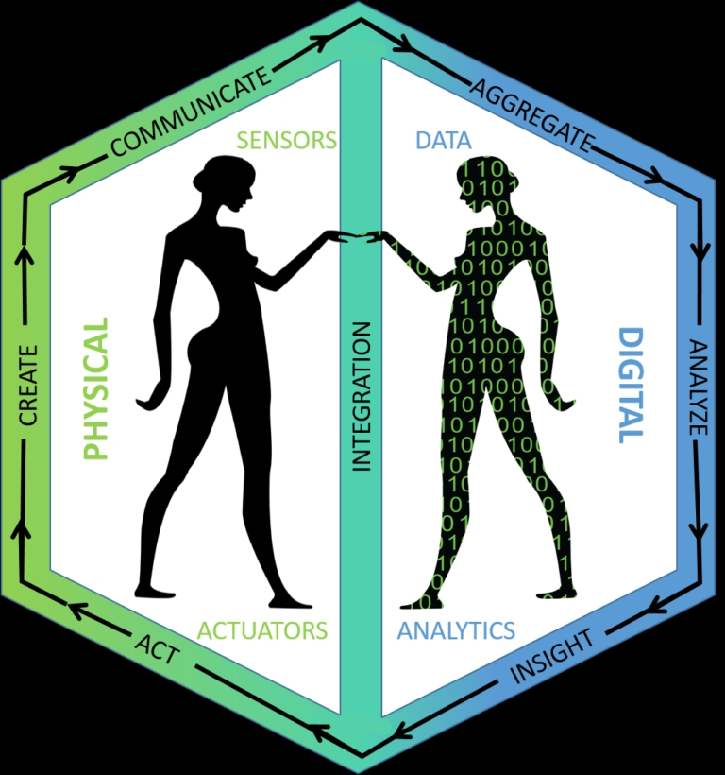

Figure 5: Work of Digital Twin

